Scott Fenton

Abdelrahman Obyat

Project Description Document

**1. Project Statement**

Our app is Sudoku Galaxy, a game that replicates the standard features of Sudoku, and adds some of our own features as well. We implemented several features into the app, including the ability to highlight errors, highlight cells, save and retrieve checkpoints, adjust difficulty, and additional unique features to improve user experience. Our game creates new Sudoku puzzles in real time, so no puzzle is every repeated. The goal of this game is to help users that want to play Sudoku, but do not have a pen and paper. This game should serve as an alternative to pen and paper Sudoku, without sacrificing the benefits of using pen and paper. Since Sudoku is a common game to play, we saw many different types of apps on the android play store with similar features, but I think that we have put our own spin on Sudoku that makes it wholly unique.

**2. Application Design**

The high-level design the game was based off the GridView presented in Homework two (Figure 1.1). We thought that this was the most logical way of approaching the overall design, because we had experience with GridView’s and the alternative methods required using an Android paint API we had no experience in. The application was initially intended to have multiple Activities, but got reduced into a single activity to make it simpler to use, and quicker to get into the game. Sudoku Galaxy targets both tablets, and phones, but it is easier to play on a tablet with the tablet screen size giving more space to expand the GridView. The main layout of our Activity consisted of two GridView’s(Figure 1.2), the first GridView held the Sudoku puzzle that was to be solved. The second GridView held the numbers one through nine, that were to be inserted into the GridView. The two GridView’s worked together so that information from one gridview could be sent to the other gridview. We included several buttons to accommodate additional features. Two buttons were used for saving the current state of the Sudoku puzzle, and loading the previous Sudoku puzzle state. The buttons worked together to remember if a save state was previously entered, and how to load that save state. A spinner was used to restart the Sudoku game on a different difficulty setting, being able to choose from either easy, medium or hard.

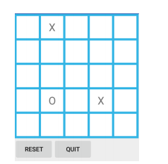 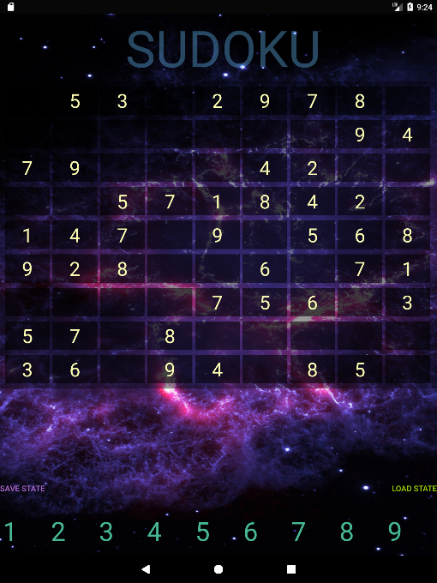

Figure 1.1 Template for our GridView Figure 1.2 Sudoku Galaxy Gridview

**3. Application Implementation and Evaluation**

The Sudoku game was a single activity application, so we decided to keep everything in one class. This turned out to be a poor idea, because it made modifying the code very difficult, and time consuming. The main feature of the game was the ability to generate Sudoku puzzles in real time, and took up a majority of our testing and performance issues. The difficulty with generating Sudoku puzzles in real time is that the performance of our algorithm would sometimes cause the application to crash because it stalled the game for too long or caused some other unexpected error. We mostly solved this problem by making the algorithm more efficient, and limiting the amount of calls we made to generate the puzzle itself. Other odd problems that we identified were related to UI and Android version support. Initially our app only worked on an Android tablet because we were not able to resize the gridview appropriately. But after changing the layout parameters, it resized correctly for Phones and Tablets, in the android play store version. It turned out to be much more difficult to test our app on different versions of Android itself, and we were only able to physically test is on a few different devices. If we were given more time, this is probably something we would test more thoroughly, but it also felt like a problem that could never truly be solved. We were able to test the app with a couple of friends that volunteered to play the game, and that proved to be very worthwhile. We were able to find flaws with our error checking that sometimes refused to highlight cells. As well as feedback that revealed that out difficulty settings may have been a little too easy. This feedback helped us make iterative changes, and eventually bring the app to a point that we were comfortable publishing it on the android app store.

**4. References**

<https://developer.android.com/guide/topics/ui/layout/gridview.html>

<https://cdn6.bigcommerce.com/s9sf3i6p/product_images/uploaded_images/galaxy.jpg?t=1457808323>

<https://freesound.org/people/Kastenfrosch/packs/10069/>

**5. Experiences and Thoughts**

We really enjoyed doing this project, and it turned out to be a great resume builder to have a published Android app. Some of the functions that would have been nice to have in the game would have been more sound effects. It time permitted it would have been have been nice to expand on the high-level design of the application to add more activities that included the ability to import custom Sudoku puzzles, and add settings that let you change the background image, and sound settings. I found homework four to be a unique experience, and would think it would improve the class to have another homework based on security, seeing as how we do not get much experience with security in the undergraduate curriculum.